- （输入答案）scalar is the best method for scaling the following （2分）
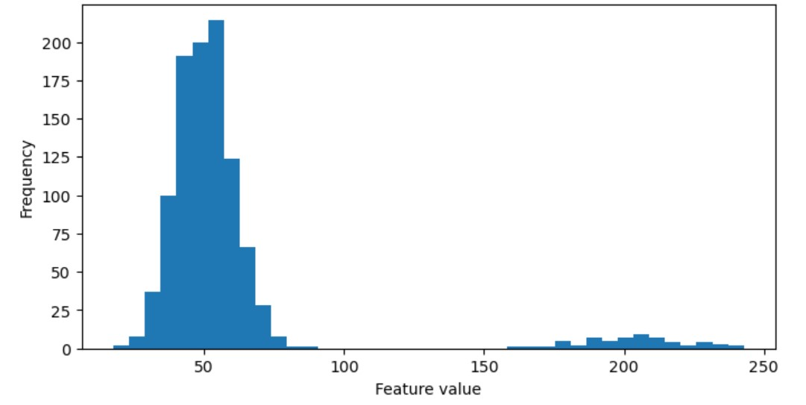
2.The primary goal of EDA.
Choose all options that are correct. Partial credit for partially correct answers. Negative marks for wrong choices.
（2分）
A.Understand data distributions, patterns, and relationships
B.Automate feature selection
C.Reduce dimensionality
D.Validate assumptions and data quality
E.Maximize model accuracy
最多可选择2个选项

3.A correlation coefficient of –0.90 between Age and Product_Views suggests:
（2分）
A.As the Age increases Product View decreases
B.None of the above
C.No linear relationship
D.As the Age increases Product View increases

